**Comparison UNet vs Cell Star segmentation**

**Visual Inspection**



The following masks are ordered as follows 🡪 Ground Truth | Cell Star Segmentation | UNet Segmentation

Undersegmentation/Oversegmentation 🡪 Cell Star appears to be undersegmenting the cells much more than Unet

False Positives/Negatives 🡪 Major presence of false negatives, especially in CellStar results. Both present a number of false positives low, but present.

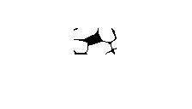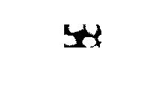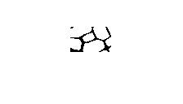

Cell contour accuracy 🡪 Cell contour in UNet results is much more accurate than the results from Cell-Star

Detection of cells near boundaries 🡪 Cell Star in general fails to detect cells near the image boundaries, an issue that does not occur in UNet segmentation.

Overlay of both masks 🡪 Left ground truth with Cell Star, right ground truth with UNet

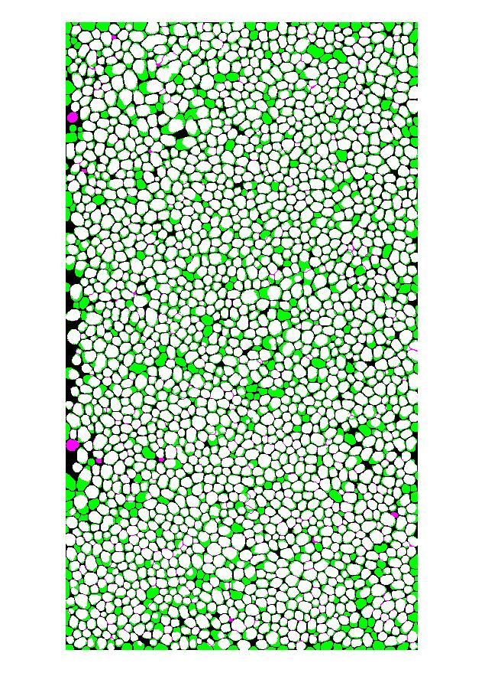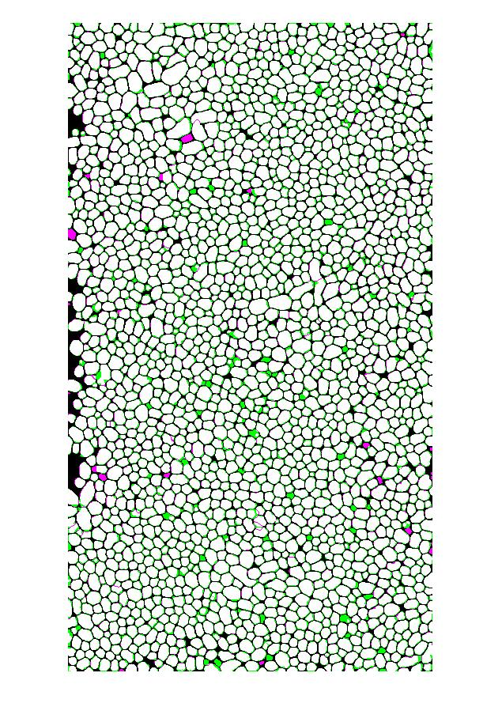

**Automatic Evaluation**

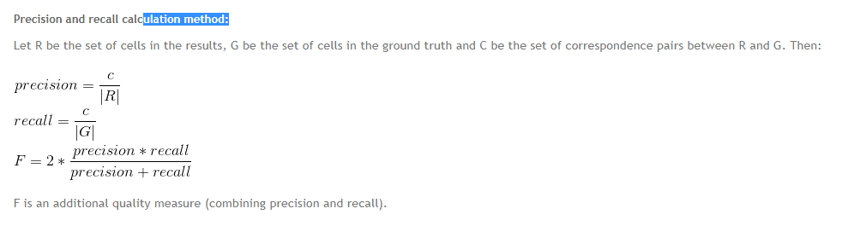

Precision results 🡪 Cell star scored 0.9854 and UNet scored 0.9708

Recall results 🡪 Cell star scored 0.9000 and UNet scored 0.9800

F results 🡪 Cell star scored 0.9408 and UNet scored 0.9754

Comparison in number of cells detected 🡪 Number of cells in ground truth is 2099, number of cells detected by Cell Star is 1917 and number of cells detected by UNet is 2119

Comparison of number of pixels detected as cell or background correctly (does not account cell shape or anything, only a binary decision on the pixels) 🡪 Cell star is 0.7440 and UNet is 0.8863.

Comparison of metrics by matlab functions (Check <https://uk.mathworks.com/help/vision/ref/evaluatesemanticsegmentation.html> for their definition)

* Cell Star 🡪

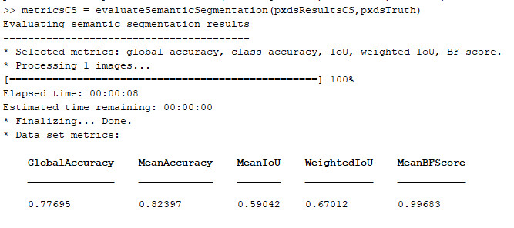

* UNet 🡪

